**IFT 533: Data Visualization & Reporting for IT**

Alok Sinha, Divyansh Rajesh Gupta, Jahnavi Singh, Sanskruti Suryabhan Jalte

Project Phase 2

Decision Making

04/14/2024

# Section 1: Used Visualization Tools

We would be using Tableau as a visualization for this project.

# Section 2: Required Data Pre-Processing

Data pre-processing required on attributes for this database-

1. Few data points in size attributes are set as ‘Not Defined’, these values would be excluded in the visualizations.

# Section 3: Final Questions

1. What is the daily sales trend?
2. How do sales vary by hour throughout the day?
3. What is the trend in product category sales?
4. What is the correlation between product and billing amount?
5. How does the transaction quantity vary across different product categories on a given day?
6. Which product detail or type within the coffee category has the highest overall transaction quantity?
7. Which drink is the top seller during each hour?
8. How does the daily sales volume vary across different drinks?
9. How does the sales volume of each product category evolve over the course of 6 months?
10. How do transaction counts fluctuate over different hours of the day?

# Section 4: Dashboard Plot Drafts

* The visualization displays the daily sales trend over a week, shown as a bar chart with the x-axis representing the days and the y-axis representing the total sales amount for each day.
* The filter used here is store location
* This chart demonstrates how sales fluctuate over time, allowing viewers to identify any patterns or trends in sales performance.
* Pre-attentive attribute used is the length of the bar.

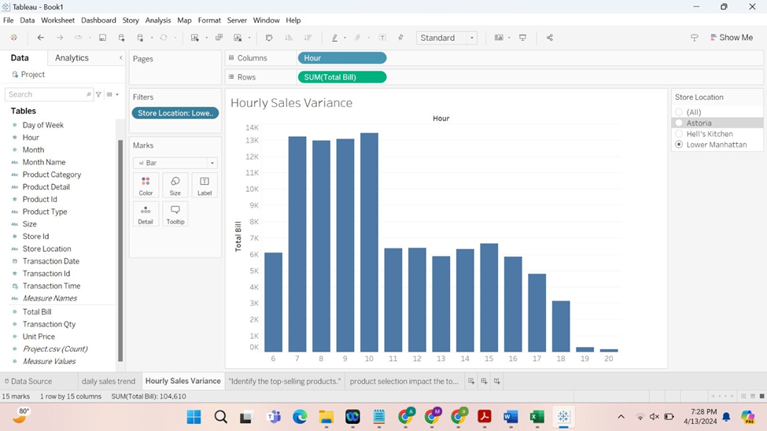

* The visualization displays the hourly sales trend over a week, shown as a bar chart with the x-axis representing the hours and the y-axis representing the total sales amount for each day.
* The filter used here is store location
* Pre-attentive attribute used is the length of the bar.

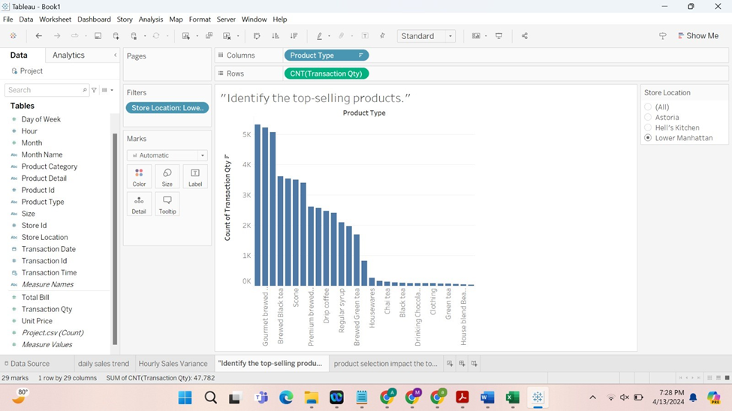

* The visualization represents the top selling product by using the product type in y axis and the count of the product in x axis.
* The filter used here is store location to identify the top selling product.
* It visualizes top selling products in each location.
* Pre-attentive attribute used is the length of the bar.

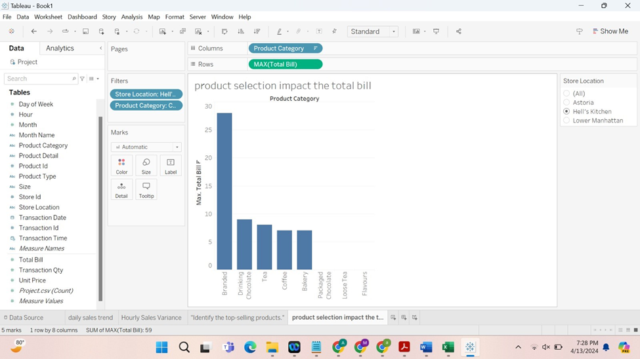

* The graph illustrates how the billing amount varies across different store locations based on the highest-selling product category.

* It visually represents the correlation between store locations and the dominant product category in terms of sales, highlighting variations in billing amounts.
* Pre-attentive attribute used is the length of the bar.

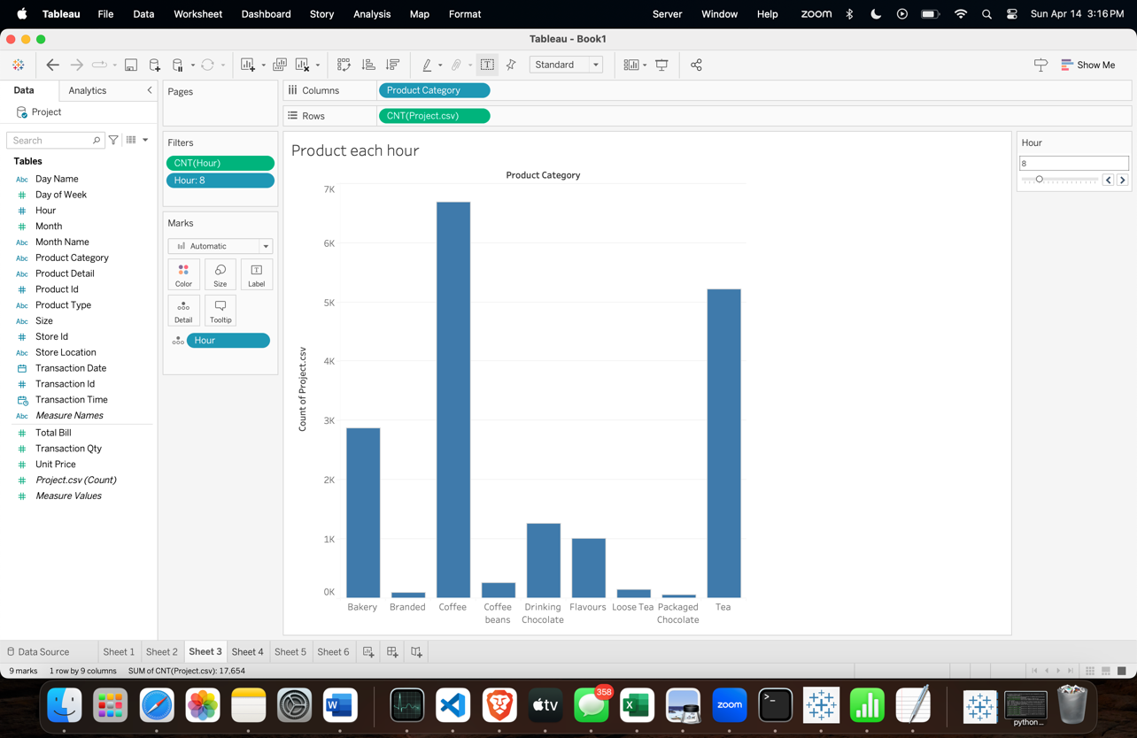

* The above plot shows the sales of each product category for each hour in the 6-month period. It displays what the hourly trend of sales of products is throughout the day.
* It uses a filter for hours in a day
* Pre-attentive attribute used is the length of the bar.

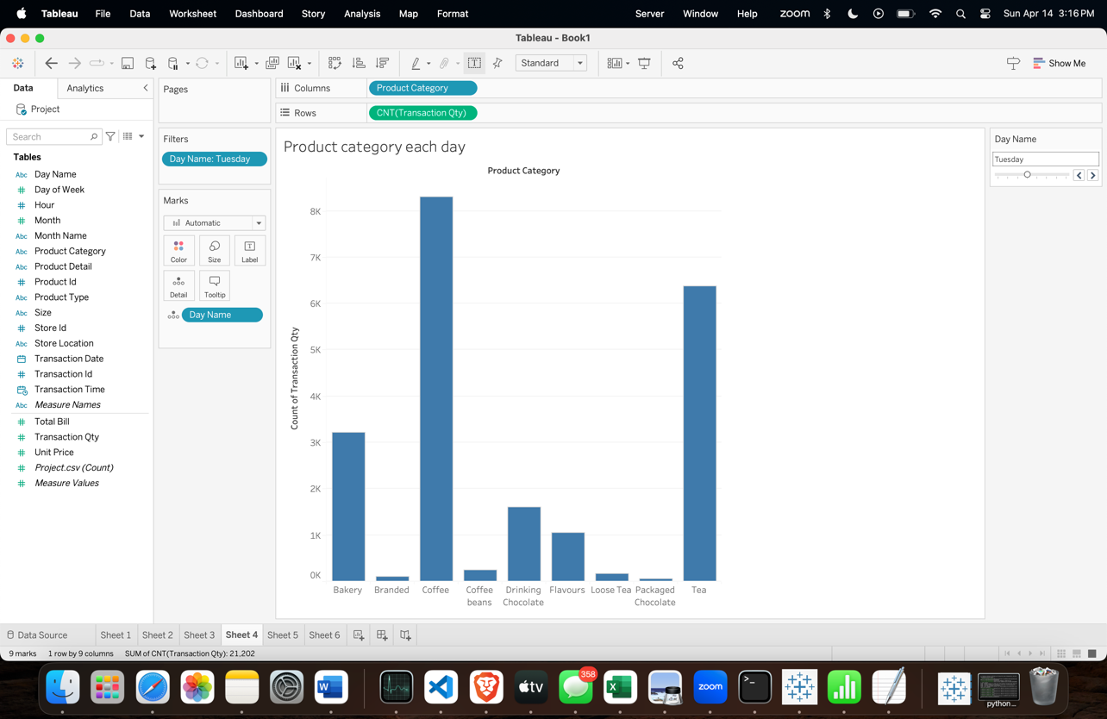

* The above plot shows the sale of each product category for each day of the week in the 6-month period. It displays what the daily trend of sales of products throughout the week is.
* It uses a filter for days in the week.
* Pre-attentive attribute used is the length of the bar.

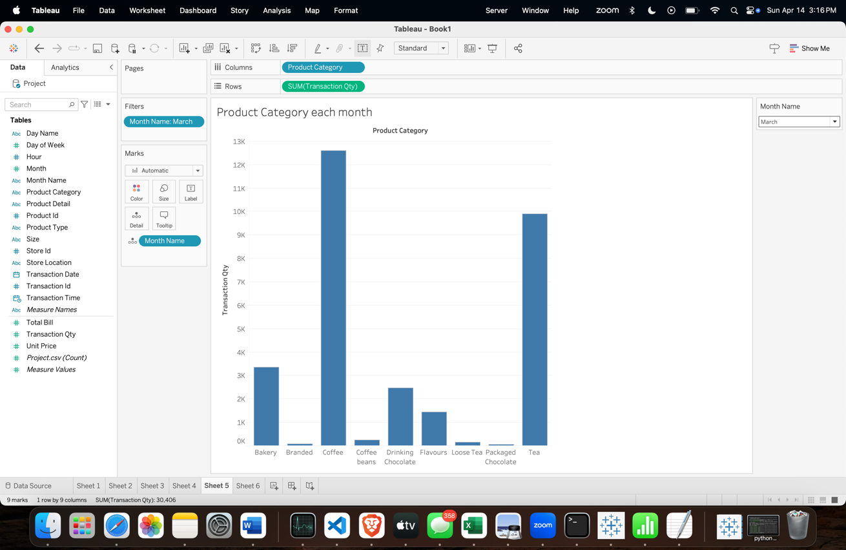

* The above plot shows the sale of each product category for a month in the 6-month period. It displays what is monthly trend of sales of products throughout the 6-month period.
* It uses a filter for months in the dataset.
* Pre-attentive attribute used is the length of the bar.

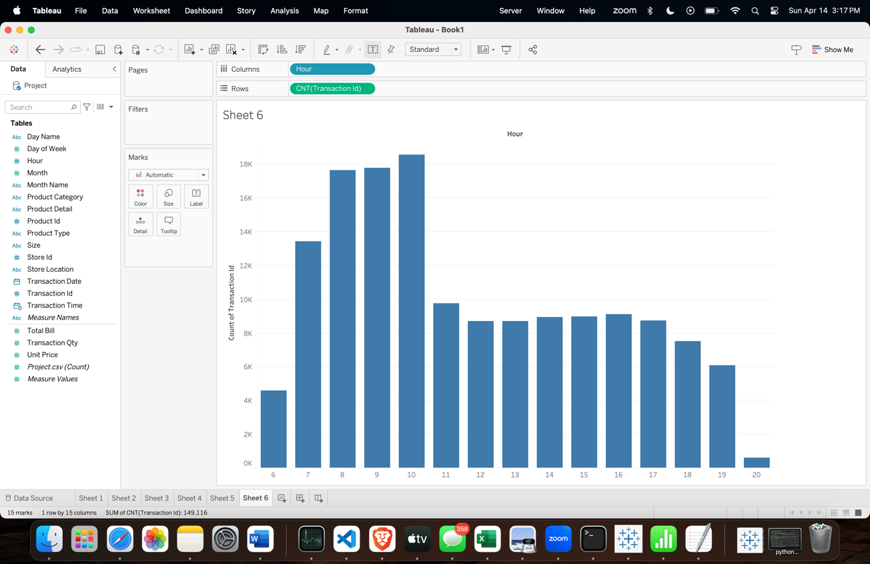

* This is a simple plot with no filters, it shows the fluctuations in the orders placed throughout the day during different hours of operation of the coffee shop. This plot shows the trends in busy and slow periods of the day in the shop.
* Pre-attentive attribute used is length of the bar.

* This is a bar chart visualization showing the transaction quantity (sum of Transaction Qty) per day for different product categories.
* The x-axis represents the days of the week, starting from Sunday and ending on Saturday.
* The y-axis represents the sum of transaction quantities, showing a range from 0 to around 30,000.
* On the right side, there is a legend for filter showing checkboxes for different product categories, allowing the user to filter the data by selecting or deselecting specific categories.
* Pre-attentive attribute used is the length of the bar.

* This is another bar chart visualization, but it displays the transaction quantity (sum of Transaction Qty) per month for different product categories.
* The x-axis represents the months of the year, showing data for January through June.
* The y-axis represents the sum of transaction quantities, ranging from 0 to around 50,000.
* On the right side, there is a legend with checkboxes for different product categories, allowing the user to filter the data by selecting or deselecting specific categories.
* Additionally, there is a filter option at the top, allowing the user to filter the data based on the "Product Category" dimension.
* Pre-attentive attribute used is the length of the bar.

* This is a horizontal bar chart visualization showing the most selling product type in each product category.
* The x-axis represents the sum of transaction quantities, ranging from 0 to around 14,000.
* The y-axis displays the product details or specific product types within each category.
* The length of bars corresponds to the total transaction quantity for that particular product type.
* On the right side, there is a drop-down menu that allows the user to filter the data by selecting a specific product category.
* The chart displays product types like "Brazilian Capuccino," "Colombian Medium," "Ethiopia Espresso shot," "Jamaican Latte Coffee," and others, providing insight into the best-selling products within each category.
* Pre-attentive attribute used is the length of the bar.

# Section 5: Dashboard Interactivity

The above

The above 4 plots use the same interactive control-filter.

The filter used is for the location of the coffee stores in the city. These filters can separate out the data for each different location.

There 3 different values in this filter – [Astoria, Hell’s kitchen, Lower Manhattan]

This above graph uses a filter to get results for each hour.

Value range – [6,7,8,9,10,11,12,13,14,15,16,17,18,19,20]

This above graph uses a filter to get results for each day of the week.

Value range – [Monday, Tuesday, Wednesday, Thursday, Friday, Saturday, Sunday]

This above graph uses a filter to get results for each month for the first 6 months of the year.

Value range – [January, February, March, April, May ,June]

This above graph does not use any filters.

The above given 4 plots use the same filter to filter out different product categories over a week, month and to check most selling product in each product cateogory.

Range of values- [Bakery, Branded, Coffee, Coffee beans, Drinking chocolate, Flavours, Loose Tea, Packaged Chocolate, Tea]

**Section 6**

**Mural Link -** <https://app.mural.co/t/datainferno5748/m/datainferno5748/1712259109140/ff0818ea885e7263f6f069800b5df742a0216c9a?fromVisitorModal=true&sender=ud544db5d5d6edeba0d556964>

References

<https://www.kaggle.com/datasets/divu2001/coffee-shop-sales-analysis>

<https://www.tableau.com/trial/tableau-prep?utm_campaign_id=2017049&utm_campaign=Prospecting-CORE-ALL-ALL-ALL-ALL&utm_medium=Paid+Search&utm_source=Google+Search&utm_language=EN&utm_country=USCA&kw=tableau%20data%20prep&adgroup=CTX-Brand-Tableau+Prep-E&adused=RESP&matchtype=e&placement=&d=7013y000000vYhH&nc=7013y0000029zDPAAY&cq_cmp=1695532765&cq_net=g&cq_plac=&gad_source=1&gclid=CjwKCAjw_e2wBhAEEiwAyFFFo-9cHE7ntmKaef5ckoMEjir0GD56ZH74ALbhSXcqBwEi-D59e0lfuhoCg4sQAvD_BwE&gclsrc=aw.ds>